Les jours de la semaine
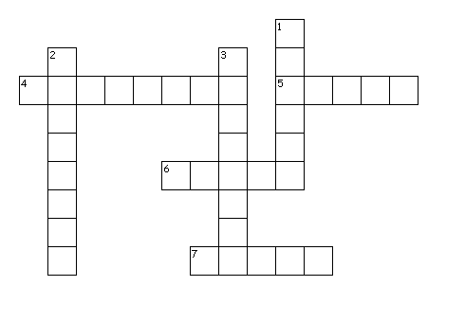

Horizontal
4. wednesday
5. tuesday
6. monday
7. thursday

Vertical
1. saturday
2. friday
3. sunday

Les jours de la semaine

Horizontal
4. wednesday
5. tuesday
6. monday
7. thursday

Vertical
1. saturday
2. friday
3. sunday

